Title: | Software Subsystem Design Description <ElectronicServices Subsystem>
Distribution
Author | Sunil S. Patil | Date: 2021-02-08
Review | see review section | see review section
Approved
Contents

1 Context 4
1.1 Scope 4
1.2 Subsystem Definitions 4
1.3 Acronyms and Abbreviations 4
2 Data Sheet 4
3 Detailed Description 5
3.1 Concept 5
3.2 Class Diagram 6
3.3 Use Cases 8
3.4 Objects List 9
3.5 VT5 speicified Objects List 18
3.6 Application Interface 24
3.6.1 RAM Test 24
3.6.1.1 State Machine 24
3.6.1.2 Address Bus Test 25
3.6.1.3 Data Bus Test 26
3.6.1.4 Data Retention Test 27
3.6.1.5 Handling RAM Test Inside the Task 28
3.6.2 ROM Test 28
3.6.2.1 Handling ROM Test Inside the Task 29
3.6.3 Micro Test 29
3.6.4 IO Pin Test 29
3.6.4.1 Pull-Up and Pull-Down Test 29
3.6.4.2 Short and Open Connection Test 29
3.6.5 Push Button and DIP switch handling 30
3.6.5.1 DIP 2 and DIP3 Handling 30
3.6.5.2 DIP1 function 31
3.6.6 Voltage Supply Monitoring 32
3.6.7 Electronic Temperature Monitoring 32
3.6.8 System Reset 33
3.6.9 Current Output Monitoring 33
3.6.10 Dynamic Variables Check 33
3.6.11 Write Protection 33
3.6.12 Cyclic Data Asynchronous Save 34
3.6.13 Reset To Default 34
3.6.14 Load Rom Default 34
3.6.15 Save As Default 34
3.6.16 Initialize NV 34
3.6.17 CheckDataCrc 34
3.6.18 CheckCrcData_ElectronicServices 35
3.6.19 Program sequence monitor 35
3.7 VT5 specified Application 36
3.7.1 Flash operation 36
3.7.2 Frontend board command 36
3.7.3 PushButton function 37
References 37
Revision Chart 37
Review 37

List of Figures
Figure 1: Class Diagram for ElectronicServices Subsystem 7
Figure 2: Use Case for ElectronicServices Subsystem 8
Figure 3: RAM test State machine. 25
Figure 4: Address Bus Test Diagram 26
Figure 5: Data Bus Test Diagram 27
Figure 6: Data Retention Test Diagram 28
Figure 7 : State diagram for Push buttons 30
Figure 8 : Collaboration diagram for DIP switches 31
Figure 9 : Collaboration diagram for Write protect switch 31
Figure 10: Entity diagram for write protect 32
Figure 11 Program sequence monitor diagram 35

List of Tables
Table 1: DIP2 and DIP3 handling 30
Table 2: Write protection configuration 33

1 Context

This document is a representation of analysis, planning, implementation and decision-making for the 2Wire Common Topworks project’s “ElectronicServices” subsystem on Communication Board.

Scope

This document describes the functional design specification for the “ElectronicServices” subsystem of 2Wire Common Topworks project. This document covers the design of “ElectronicServices” subsystem on the CB only.

Subsystem Definitions

Coordinatore Subsystem | 2wire subsystem providing initialization and scheduling
HART Subsystem | 2wire subsystem for interfacing to HART (Highway Addressable Remote Transducer) protocol communications.

Acronyms and Abbreviations

2wire platform | Based on 266 design, improve the re-use of previous common components to build a new platform for ABB 2wire devices.
HART | Highway Addressable Remote Transducer
HMI | Human Machine Interface
N/A | Not Applicable
TBD | To Be Determined
FE | Front-end Board
CB | Communication Board
ES | Electronic Services

Data Sheet

This chapter gives an overview about all important facts of the subsystem. It can be used by a developer who would like to reuse this subsystem.

Category | Item | Description
Development | Version / Status | Version 1.3.1
Development | Known Bugs | Not known
Development | Planned Improvements | None
HW-Platform | Type | M16C63
HW-Platform | Clocking | 3.6MHz
SW-Development Environment | Compiler | IAR M16C 3.40
SW-Development Environment | Operating System | Segger embOS for M16C version 3.28g
SW-Development Environment | Case / Code-Generation Tool | EntryTool 1.1.3
Required Resources | Operating System | None
Required Resources | HW | 2Wire CB
Required Resources | RAM | No design restriction. Entire RAM can be used
Required Resources | NVRAM | 56 Byte
Required Resources | ROM | None
Required Resources | Execution Time | None
Required Resources | Special HW | None
Required Resources | Subsystems | Coordinator Subsystem  HART Subsystem
Required Resources | Data Objects | For detail, Please refer 3.4 Objects List
Standards | Safety | DIN 61508 SIL 2, 2010
Standards | Other | Namur NE 107
Documentation | Requirements / Use Cases | Refer to 3.3 Use Cases
Documentation | Public Interface Description | Refer to 3.5 Application Interface
Documentation | Test Specification | Refer to[2]

Detailed Description

Concept

ES subsystem provide following functionalities:

- RAM Test: Check the correct functionality of the RAM.
- ROM Test: Check for the intactness of the data in Flash. Do a CRC checking.
- Micro Testing: Test instruction sets and registers
- IO Pin Test: Test the shortage and open between each closed pins; and also test the shortage and open about pull up and pull down circuit
- Push Button and DIP Switch Handling.
- Voltage Supply Monitoring: Checks the range.
- Handles The Electronic Temperature for Current Output Compensation.
- System Reset: Provide a method to execute self system reset
- Current Out Read Back.
- Duplicated Dynamic Variables Check.
- Static Data CRC16 Check.
- Device “Write proctection”.
- Cyclic Asynchronous Saving.
- Reset To Default: Provide a method to reset some variables to default which have default value stored in NV memory
- Load Rom Default: Provide a method to initialize some variables with ROM default value
- Save As Default: Provide a method to save variables as default value which also be saved in NV memory
- Initialize NV: Reset NV to factory setting.

Design of each functionalities is described in subsequent paragraphs.

Note: The ES subsystem consists of many functionalities, most of them are independent and doesn’t relate to any other subsystems.

Class Diagram

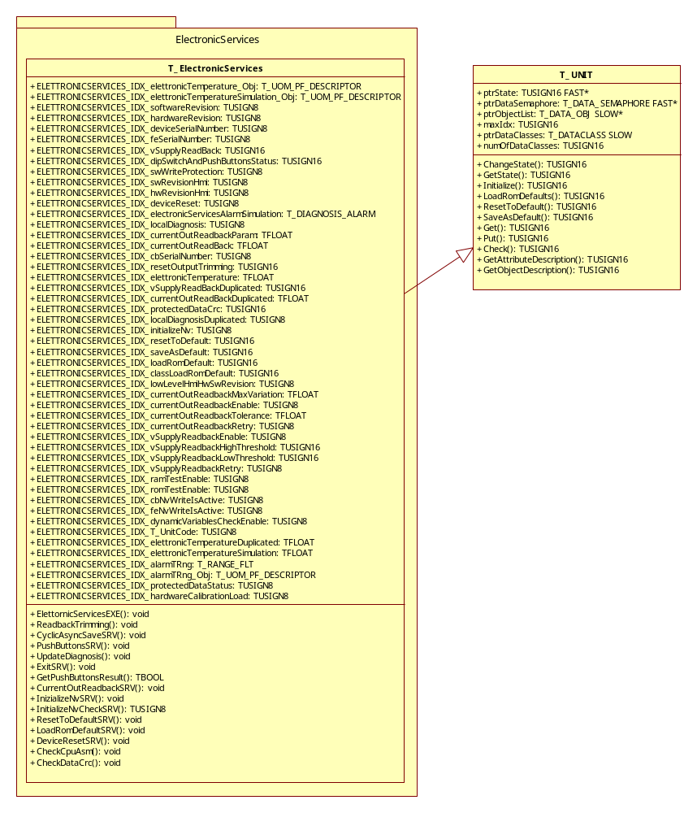
Figure 1: Class Diagram for ElectronicServices Subsystem

Use Cases

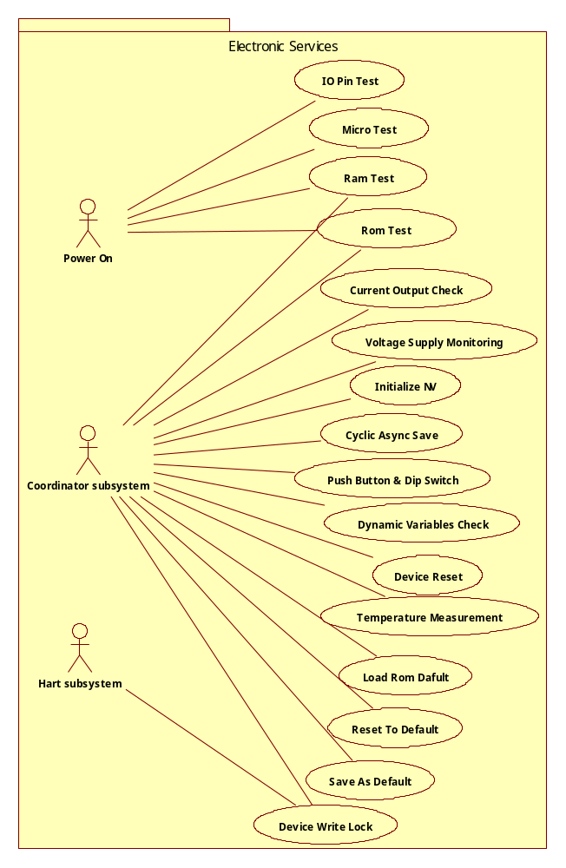
Figure 2: Use Case for ElectronicServices Subsystem

Objects List

- elettronicTemperature_Obj
Data type: | T_UOM_PF_DESCRIPTOR
Storage: | ROM
Data class: | Const
Attributes: | T_DATA_OBJ unit  T_DATA_OBJ value  T_UOM_PF_TYPE unitsType
Description: | Descriptor of temperature

- elettronicTemperatureSimulation_Obj
Data type: | T_UOM_PF_DESCRIPTOR
Storage: | ROM
Data class: | CONST
Attributes: | T_DATA_OBJ unit  T_DATA_OBJ value  T_UOM_PF_TYPE unitsType
Description: | Descriptor of simulation temperature

- softwareRevision
Data type: | SIMPLE_U8
Storage: | ROM
Data class: | CONSTANT
Attributes: | -
Description: | Software revision

- hardwareRevision
Data type: | SIMPLE_U8
Storage: | NON VOLATILE
Data class: | STATIC RARE
Attributes: | -
Description: | Hardware revision

- deviceSerialNumber
Data type: | SIMPLE_CHAR[6]
Storage: | NON VOLATILE
Data class: | STATIC RARE
Attributes: | -
Description: | Device serial number

- vSupplyReadback
Data type: | TUSIGN16
Storage: | RAM
Data class: | DYNAMIC DUPLICATED
Attributes: | -
Description: | Last supply voltage value in ms stored.

- dipSwitchAndPushButtonsStatus
Data type: | TUSIGN16
Storage: | READ ONLY RAM
Data class: | UNPROTECTED
Attributes: | -
Description: | Bit string for dip switches and push buttons activation.

- swWriteProtect
Data type: | TABENUM8
Storage: | NON VOLATILE
Data class: | REPLACE STATIC FREQUENT NO DEFAULT
Attributes: | -
Description: | Software write protect status

- swRevisionHmi
Data type: | SIMPLE_CHAR[17]
Storage: | RAM
Data class: | UNPROTECTED
Attributes: | -
Description: | Device serial number

- hwRevisionHmi
Data type: | SIMPLE_CHAR[17]
Storage: | RAM
Data class: | UNPROTECTED
Attributes: | -
Description: | Device serial number

- deviceReset
Data type: | ACTION
Storage: | -
Data class: | -
Attributes: | -
Description: | Perform the device reboot

- electronicServicesAlarmSimulation
Data type: | T_DIAGNOSIS_ALARM
Storage: | RAM
Data class: | PROTECTED
Attributes: | -
Description: | Bit string for diagnosis simulation bits

- localDiagnosis
Data type: | SIMPLE_U8
Storage: | RAM
Data class: | DYNAMIC DUPLICATED
Attributes: | -
Description: | Internal diagnosis

- currentOutReadbackParam
Data type: | TFLOAT
Storage: | NON VOLATILE
Data class: | STATIC FREQUENT STATIC DEFAULT
Attributes: | -
Description: | Current out read-back parameters (gain, offset)

- currentOutReadback
Data type: | TFLOAT
Storage: | RAM
Data class: | DYNAMIC DUPLICATED
Attributes: | -
Description: | Last current out in read-back stored

- cbSerialNumber
Data type: | SIMPLE_U8
Storage: | NON VOLATILE
Data class: | REPLACE STATIC RARE
Attributes: | -
Description: | Communication board serial number. Writable on via private command

- resetOutputTrimming
Data type: | ACTION
Storage: | -
Data class: | -
Attributes: | -
Description: | Reset current out trimming parameters

- elettronicTemperature
Data type: | TFLOAT
Storage: | RAM
Data class: | DYNAMIC DUPLICATED
Attributes: | -
Description: | Last temperature value

- vSupplyReadbackDuplicated
Data type: | TUSIGN16
Storage: | RAM
Data class: | DYNAMIC DUPLICATED
Attributes: | -
Description: | Duplicated value for dynamic check function

- currentOutReadbackDuplicated
Data type: | TFLOAT
Storage: | RAM
Data class: | DYNAMIC DUPLICATED
Attributes: | -
Description: | Duplicated value for dynamic check function

- protectedDataCrc
Data type: | TUSIGN16
Storage: | RAM
Data class: | UNPROTECTED
Attributes: | -
Description: | CRC value of protected variables

- localDiagnosisDuplicated
Data type: | SIMPLE_U8
Storage: | RAM
Data class: | DYNAMIC DUPLICATED
Attributes: | -
Description: | Duplicated value for dynamic check function

- initializeNv
Data type: | TABENUM8
Storage: | RAM
Data class: | UNPROTECTED
Attributes: | -
Description: | Nv initialization code. Writable only via private command

- resetToDefault
Data type: | SIMPLE_I16
Storage: | RAM
Data class: | UNPROTECTED
Attributes: | -
Description: | Reset to default subsystem code

- saveAsDefault
Data type: | SIMPLE_I16
Storage: | RAM
Data class: | UNPROTECTED
Attributes: | -
Description: | Save as default subsystem code

- loadRomDefault
Data type: | SIMPLE_I16
Storage: | RAM
Data class: | UNPROTECTED
Attributes: | -
Description: | Load rom default subsystem code

- classLoadRomDefault
Data type: | SIMPLE_I16
Storage: | RAM
Data class: | UNPROTECTED
Attributes: | -
Description: | Load rom default subsystem dataclass code

- lowLevelHmiHwSwRevision
Data type: | SIMPLE_CHAR[8]
Storage: | RAM
Data class: | UNPROTECTED
Attributes: | -
Description: | Low level hmi revisions

- currentOutReadbackMaxVariation
Data type: | TFLOAT
Storage: | RAM
Data class: | UNPROTECTED
Attributes: | -
Description: | Max variation between value read and tolerance

- currentOutReadbackEnable
Data type: | TABENUM8
Storage: | NON VOLATILE
Data class: | REPLACE STATIC FREQUENT NO DEFUALT
Attributes: | -
Description: | Current out read-back function enable

- currentOutReadbackTolerance
Data type: | TFLOAT
Storage: | NON VOLATILE
Data class: | REPLACE STATIC FREQUENT NO DEFUALT
Attributes: | -
Description: | Current out read-back function tolerance in mA

- currentOutReadbackRetry
Data type: | SIMPLE_U8
Storage: | NON VOLATILE
Data class: | REPLACE STATIC FREQUENT NO DEFUALT
Attributes: | -
Description: | Current out read-back function retry

- vSupplyReadbackEnable
Data type: | TABENUM8
Storage: | NON VOLATILE
Data class: | REPLACE STATIC FREQUENT NO DEFUALT
Attributes: | -
Description: | Power supply read-back function enable

- vSupplyReadbackHighThreshold
Data type: | TFLOAT
Storage: | NON VOLATILE
Data class: | REPLACE STATIC FREQUENT NO DEFUALT
Attributes: | -
Description: | Power supply read-back function high threshold

- vSupplyReadbackLowThreshold
Data type: | TFLOAT
Storage: | NON VOLATILE
Data class: | REPLACE STATIC FREQUENT NO DEFUALT
Attributes: | -
Description: | Power supply read-back function low threshold

- vSupplyReadbackRetry
Data type: | SIMPLE_U8
Storage: | NON VOLATILE
Data class: | REPLACE STATIC FREQUENT NO DEFUALT
Attributes: | -
Description: | Power supply read-back function retry

- ramTestEnable
Data type: | TABENUM8
Storage: | NON VOLATILE
Data class: | REPLACE STATIC FREQUENT NO DEFUALT
Attributes: | -
Description: | Ram test function enable

- romTestEnable
Data type: | TABENUM8
Storage: | NON VOLATILE
Data class: | REPLACE STATIC FREQUENT NO DEFUALT
Attributes: | -
Description: | Rom test function enable

- cbNvWriteIsActive
Data type: | TABENUM8
Storage: | RAM
Data class: | UNPROTECTED
Attributes: | -
Description: | True during a communication board nv writing

- feNvWriteIsActive
Data type: | TABENUM8
Storage: | RAM
Data class: | UNPROTECTED
Attributes: | -
Description: | True during a replace fe nv writing

- dynamicVariablesCheckEnable
Data type: | TABENUM8
Storage: | NON VOLATILE
Data class: | REPLACE STATIC FREQUENT NO DEFUALT
Attributes: | -
Description: | Dynamic variable check enable for SIL intent

- T_UnitCode
Data type: | TABENUM8
Storage: | NON_VOLATILE
Data class: | STATIC_RARE
Attributes: | -
Description: | Unit code of temperature

- elettronicTemperatureDuplicated
Data type: | TFLOAT
Storage: | RAM
Data class: | DYNAMIC DUPLICATED
Attributes: | -
Description: | Duplicated for dynamic check function

- elettronicTemperatureSimulation
Data type: | TFLOAT
Storage: | RAM
Data class: | PROTECTED
Attributes: | -
Description: | Simulate temperature value

- alarmTRng
Data type: | RANGEFLT
Storage: | NON_VOLATILE
Data class: | STATIC_RARE
Attributes: | TFLOAT hiLim  TFLOAT loLim
Description: | Range for alarm

- alarmTRng_Obj
Data type: | T_UOM_PF_DESCRIPTOR
Storage: | -
Data class: | -
Attributes: | -
Description: | Descriptor of temperature alarm

- protectedDataStatus
Data type: | TABENUM8
Storage: | RAM
Data class: | PROTECTED
Attributes: | -
Description: | Status of protected data

- hardwareCalibrationLoad
Data type: | RANGEFLT
Storage: | NON_VOLATILE
Data class: | STATIC_RARE
Attributes: | TFLOAT hiLim  TFLOAT loLim
Description: | Stand for hardware calibration flag

VT5 speicified Objects List
- feSerialNumber
Data type: | SIMPLE_CHAR[8]
Storage: | NON VOLATILE
Data class: | STATIC RARE
Attributes: | -
Description: | Frontend board serial number

- sensorID
Data type: | SIMPLE_CHAR[8]
Storage: | NON VOLATILE
Data class: | STATIC RARE
Attributes: | -
Description: | Sensor ID number

- sensorSapErpNo
Data type: | SIMPLE_CHAR[20]
Storage: | NON VOLATILE
Data class: | STATIC RARE
Attributes: | -
Description: | Sensor Sap number

- sensorCalDate
Data type: | SIMPLE_CHAR[12]
Storage: | NON VOLATILE
Data class: | STATIC RARE
Attributes: | -
Description: | Sensor calibration date

- sensorCalCertNo
Data type: | SIMPLE_CHAR[20]
Storage: | NON VOLATILE
Data class: | STATIC RARE
Attributes: | -
Description: | Sensor calibration certificate number

- sensorCalLocation
Data type: | SIMPLE_CHAR[20]
Storage: | NON VOLATILE
Data class: | STATIC RARE
Attributes: | -
Description: | Sensor calibration location

- bootloaderRevision
Data type: | SIMPLE_CHAR[8]
Storage: | NON VOLATILE
Data class: | STATIC RARE
Attributes: | -
Description: | Bootloader software version

- tranType
Data type: | SIMPLE_CHAR[12]
Storage: | NON VOLATILE
Data class: | STATIC RARE
Attributes: | -
Description: | Transmit type

- tranID
Data type: | SIMPLE_CHAR[8]
Storage: | NON VOLATILE
Data class: | STATIC RARE
Attributes: | -
Description: | Transmit ID

- tranSapErpNo
Data type: | SIMPLE_CHAR[20]
Storage: | NON VOLATILE
Data class: | STATIC RARE
Attributes: | -
Description: | Transmit Sap number

- tranCalDate
Data type: | SIMPLE_CHAR[12]
Storage: | NON VOLATILE
Data class: | STATIC RARE
Attributes: | -
Description: | Transmit calibration date

- tranCalCertNo
Data type: | SIMPLE_CHAR[20]
Storage: | NON VOLATILE
Data class: | STATIC RARE
Attributes: | -
Description: | Transmit calibration certificate number

- tranCalLocation
Data type: | SIMPLE_CHAR[32]
Storage: | NON VOLATILE
Data class: | STATIC RARE
Attributes: | -
Description: | Transmit calibration location

- manufacturer
Data type: | SIMPLE_CHAR[20]
Storage: | NON VOLATILE
Data class: | STATIC RARE
Attributes: | -
Description: | Device manufacturer

- street
Data type: | SIMPLE_CHAR[20]
Storage: | NON VOLATILE
Data class: | STATIC RARE
Attributes: | -
Description: | Manufacturer street

- city
Data type: | SIMPLE_CHAR[20]
Storage: | NON VOLATILE
Data class: | STATIC RARE
Attributes: | -
Description: | Manufacturer city

- phone
Data type: | SIMPLE_CHAR[20]
Storage: | NON VOLATILE
Data class: | STATIC RARE
Attributes: | -
Description: | Manufacturer phone

- writeAutoZero
Data type: | ACTION
Storage: | -
Data class: | -
Attributes: | -
Description: | Write auto zero action

- writeSelfDiagnosis
Data type: | ACTION
Storage: | -
Data class: | -
Attributes: | -
Description: | Write self diagnosis action

- resetCB_Runhour
Data type: | ACTION
Storage: | -
Data class: | -
Attributes: | -
Description: | Reset CB run hour

- frontendRtc
Data type: | SIMPLE_CHAR[5]
Storage: | RAM
Data class: | UNPROTECTED
Attributes: | -
Description: | Frontend board RTC

- autozeroStatus
Data type: | TABENUM8
Storage: | RAM
Data class: | UNPROTECTED
Attributes: | -
Description: | Frontend board autozero status

- autoSelfCheckTime
Data type: | TABENUM8
Storage: | NON VOLATILE
Data class: | STATIC RARE
Attributes: | -
Description: | Auto Self check time

- snrThreshold
Data type: | INT16
Storage: | RAM
Data class: | UPROTECTED
Attributes: | -
Description: | Frontend board SNR threshold

- sensorLocationTag
Data type: | SIMPLE_CHAR[20]
Storage: | NON VOLATILE
Data class: | STATIC RARE
Attributes: | -
Description: | Sensor location tag

- sensoTag
Data type: | SIMPLE_CHAR[20]
Storage: | NON VOLATILE
Data class: | STATIC RARE
Attributes: | -
Description: | Sensor tag

- softwareMainRevision
Data type: | SIMPLE_U8
Storage: | RAM
Data class: | UPROTECTED
Attributes: | -
Description: | Software main revision

- hardwareMainRevision
Data type: | SIMPLE_U8
Storage: | RAM
Data class: | UPROTECTED
Attributes: | -
Description: | Hardware main revision

- swRevisionHmi_fe
Data type: | SIMPLE_CHAR[8]
Storage: | RAM
Data class: | UPROTECTED
Attributes: | -
Description: | Frontend board software revision

- hwRevisionHmi_fe
Data type: | SIMPLE_CHAR[8]
Storage: | RAM
Data class: | UPROTECTED
Attributes: | -
Description: | Frontend board hardware revision

- tranSapErpNoChangeFlag
Data type: | SIMPLE_U8
Storage: | RAM
Data class: | UPROTECTED
Attributes: | -
Description: | Sap number change flag

- formatFENV
Data type: | ACTION
Storage: | -
Data class: | -
Attributes: | -
Description: | Frontend board software revision

Application Interface

RAM Test

State Machine

RAM test includes following.
- Address Bus test.
- Data Bus test.
- Data retention test.

Note: For description of each of the tests, please see below description.

The RAM test is run at the start-up and also during the run-time. If the RAM test fails during run-time or during start-up, system is put to reset by calling software reset.

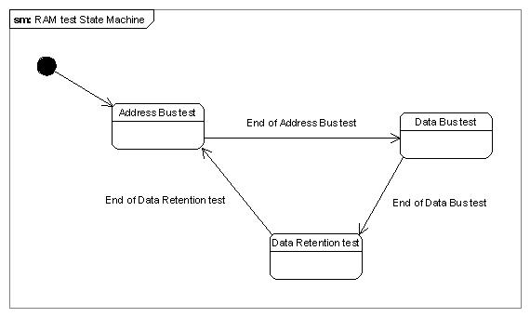

Figure 3: RAM test State machine.

Address Bus Test

This test checks the address bus for following faults.
- Stuck hi.
- Stuck lo.
- Bus discontinuity. (or Bus broken)
- Cross talks.

Logic: To check the above faults we follow the below sequence.

- Write a PATTERN into base address of the RAM. Base address of the RAM is always 0.
- Write an ANTIPATTERN into the offset address. Where offset address = (Base address + 2 power n). Value of ‘n’ ranging from 0 to “width” of the address bus.
- Read back the values from both base address and the offset address. If the values are found other than what is written, then there is a fault.
- Repeat the above steps until n = “width of the address bus”.

Note:
- PATTERN = 0x5555
- ANTIPATTERN = 0xAAAA

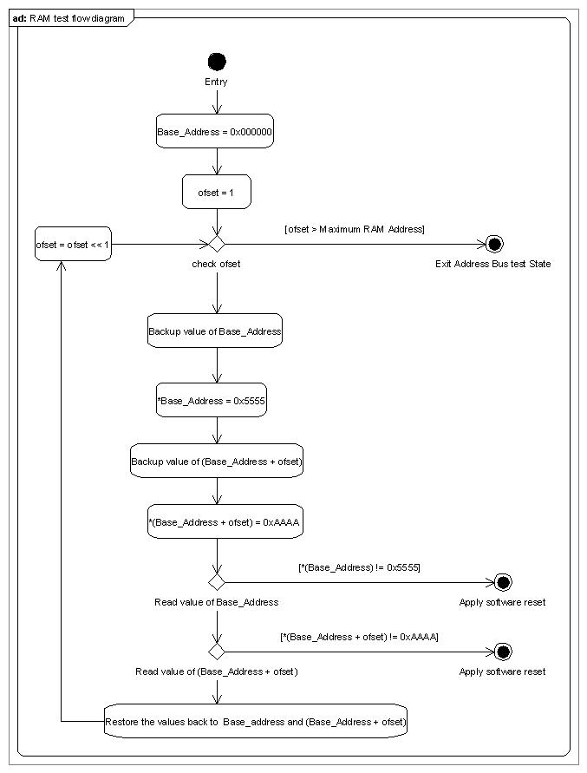
Figure 4: Address Bus Test Diagram

Data Bus Test

The data bus test checks for following faults.
- Bus stuck hi.
- Bus stuck lo.
- Bus cut.
- Cross talks.
Logic: A data bus test is performed by writing an address location with “walking one” pattern and reading back the same. If the read value doesn’t match with the written value, a fault exists. This is explained in the below flow diagram.

Note: Walking one pattern is a pattern where 1 walks along the data bus.

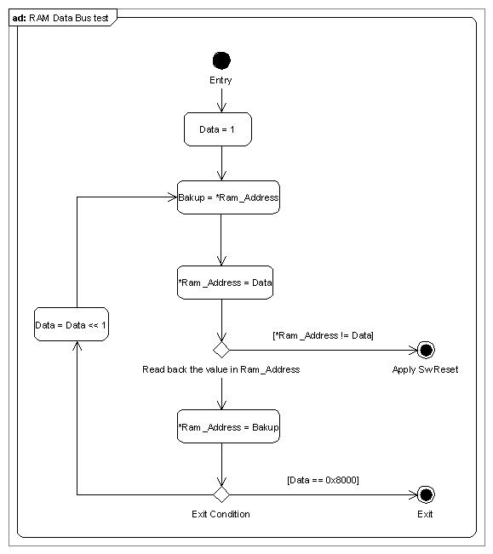
Figure 5: Data Bus Test Diagram

Data Retention Test

This test checks the capability of each memory cell to hold values both 1 and 0. This is done by writing a PATTERN (0x5555) and ANTIPATTERN (0xAAAA) into every address location alternatively. If an address location fails to hold the value, then the fault exists. The flow diagram for the above test is shown below.

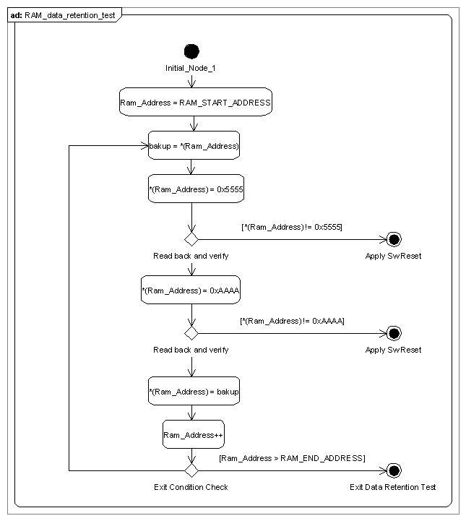
Figure 6: Data Retention Test Diagram

Handling RAM Test Inside the Task

The RAM size used for the project is very huge. Therefore, RAM test cannot be completed in one task cycle. So a portion of RAM test shall be conducted in every task cycle.

Address Bus test: Only one address bus shall be tested in each task cycle, till completion of the test.

Data Bus test: Only one data bus shall be tested in each task cycle, till completion of the test.

Data Retention test: Only one memory location is tested in each task cycle, till completion of the test.

ROM Test

ROM test is required to check the integrity of the flash content. The application firmware runs a self CRC-16 check to verify the ROM contents. ROM test is performed at start-up. Also, it is continuously performed at run-time.

Logic:
- During the burning process of the ROM, a CRC16 checksum is also stored in a predefined location of the ROM. (This location is always the beginning location of the application ROM)
- The ROM test, when executed, calculates CRC16 for the complete application ROM, excluding the beginning location where “CRC16 checksum” is stored (on itself).
- ROM test calculated CRC16 is compared with the CRC16 stored in the beginning of the application ROM.
- If they are not matching, ROM test executes a s/w reset. (This means ROM is corrupted)

Handling ROM Test Inside the Task

The application ROM size is very huge. Therefore, ROM test cannot be completed in one task cycle.
So, ROM has to be divided into blocks of 5KB. In every task cycle, CRC16 for a block of ROM shall be calculated. Later, the CRC16 of all the blocks are added to get the “Final CRC”. “Final CRC” is compared with the CRC16 already stored in the ROM. If they are found different, then it means that ROM is corrupted.

Note: The ROM test shall make use of the hardware CRC, present inside the M16C.

Micro Test

The purpose of Micro test is to check the basic functionality of microcontroller. This includes testing of instruction sets and registers.
- Data registers: R0, R1, R2 and R3. Test for both read and write operations.
- Address Registers: A0 and A1. Test for “register-based indirect addressing” and “register based relative addressing”.
- Special purpose registers:
- INTB – Interrupt table register
- FB -Frame Base register.
- USP- User stack pointer and ISP- Interrupt stack pointer
- SB – Static base register
- FLG – Flag register
- Key instructions are tested for their operation.

IO Pin Test

The purpose is to check IO pin connected correctly

Pull-Up and Pull-Down Test

- Pull-up: Read the IO pin status. High level success otherwise the test fail
- Pull-down: Read the IO pin status. Low level success otherwise the test fail
- Pull-up or Pull-down depending on setting: Read the pin status several times, if stable success otherwise the test fail.
- Hang: Do not need test

Short and Open Connection Test

- Short connection: Output high or low level to one IO pin then read the pin status from the other, if same success otherwise the test fail.
- Open connection: Output high or low level to one IO pin the read the pin status from the other, if the pin status don’t change the test success otherwise the test fail.
- Special IO pin: Some IO pin test has an influence on current out or can lead the device to a unsafe condition, the pin test is avoided.

Push Button and DIP switch handling

The functionality of push button, differ for HART, FF and PA devices.

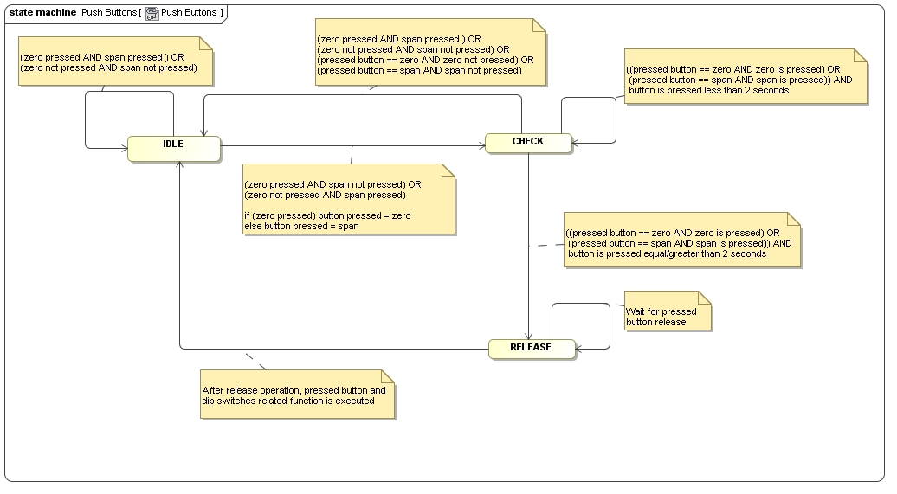
Figure 7 : State diagram for Push buttons

DIP 2 and DIP3 Handling

Following table defines the functionality of DIP2 and DIP3 switches. Only when write protection is off (See section 3.6.11 ), the replace function is activated.

Table 1: DIP2 and DIP3 handling

Communication Type | DIP 2 position  Replace Enable | DIP 3 position  Replace Direction | Description
HART/ PA/ FF | OFF | Don’t care | Replacement disabled.
HART/ PA/ FF | ON | ON | New Sensor
HART/ PA/ FF | ON | OFF | New Electronic

At the start-up, application scans for the position of DIP2 and DIP3 switches. Based on the position of DIP2 and DIP3 switches, NV contents are transferred from CB to FE or vice versa.

A collaboration diagram is shown in the following figure.

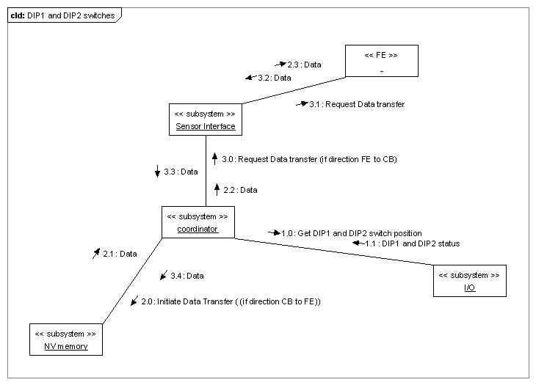
Figure 8 : Collaboration diagram for DIP switches

DIP1 function

When this button is ON state, the device is in write protect state. Only if DIP1 is OFF state and software write protection is off, data object can be wrotten by HMI or HART.

At the start-up the position of write protect switch is checked. If the write protect is ON, device is not writable. Meaning device is not configurable. (NV memory is not writable)

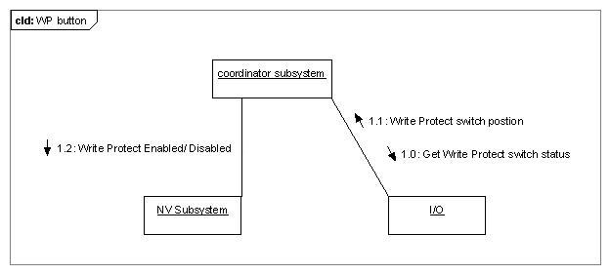
Figure 9 : Collaboration diagram for Write protect switch

The NV subsystem shall provide an object for the coordinator subsystem to enable or disable the write protect.

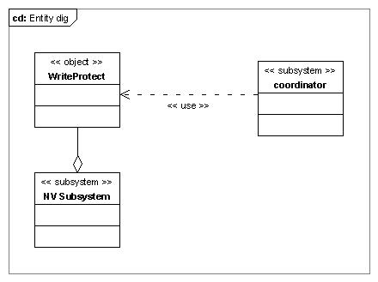
Figure 10: Entity diagram for write protect

Voltage Supply Monitoring

ADC 5 of M16C is used for voltage supply monitoring. The ADC value is of 10bit.
Raw ADC value is read and filtered. Filtered ADC value is the arithmetic mean of previously read 8 ADC values.
Filtered value shall be converted to mV unit using the below formula.

(ADC value in mV) = (Raw ADC value * Reference Voltage) / Full scale value of ADC

As per the schematics, the above value in mV is read across a resistor network. Please see the schematics for more information.
The actual supply voltage value is got by applying below formula.

Actual supply voltage = (ADC value in mV * (R4M7 + R200K))/ R200K

ES subsystem provide a method to check the supply voltage. If the supply voltage is less than 9v, a software reset is executed.

The supply voltage is also monitored to check if the voltage is dropping below 11.5v. The voltage drop below this level is monitored for 7 seconds to avolid voltage bouncing effect and if it still continues to drop then a volgate low alarm is enabled.

Electronic Temperature Monitoring

The electronic temperature needs to be monitored, because this is one of the parameters for current out calculation. Electronic temperature is read on ADC6 of M16C.
Following conversion is required for converting the raw ADC value to Voltage format.

(ADC value in mV) = (Raw ADC value * Reference Voltage) / Full scale value of ADC

ADC value in mV is converted to temperature by applying following formula.

Temperature = -1481.96 + sqrt((2.1962*1000000)+((1.8639- ADC value in mV)/(3.88*0.000001)))

ES subsystem provides a method to update the electronic temperature of the current out subsystem.

System Reset

System reset is achieved by setting inner register relative bits which will lead to CPU reset. Before setting the register, disable all interrupts first then set PWM function register to let current out output low alarm state (<=3.6mA).
It is implements as the following four steps:

- Disable all interrupts first.
- Set PWM special function register value to let current out output low alarm state (<=3.6mA).
- CPU will then set special function register value to let CPU reset. (Then alarm state is ensured by start-up network).
- If the reset action failed, CPU will then stuck in while loop, to let external HW watchdog to reset CPU.

This function is always called when system failure detected. And for other functional or user request device reset action, the below action will be called during device reset:

- Stop all other tasks.
- Save all NV data in Ram to NV chip.
- Call system reset function. This is described above.

Current Output Monitoring

This function checks the goodness of the current output stage. The current output value is read on the ADC 7 and it is compared with the last value generated from the Current-out subsystem. The maximum accepted tolerance is the 2 % of 16mA (0,32mA). If offset keeps bigger than the accepted tolerance for some times, then alarm will be send to diagnosis subsystem. The default times in ES is 3;

Dynamic Variables Check

For the Safety Function, some variables are duplicated. The dynamic variables routine checks the value in both original and duplicated variables. If two values are different, a ram failure or unhandled writing is happened. A device reset is performed.

Write Protection

For hardware write protection, please refer to 3.6.5.2.
Beside hardware write protection, the subsystem also provides software write protection by create an object which can be set through HART interface. Only if hardware write protection is off and software write protection is off, data object can be wrotten by HMI or HART, otherwise all data objects are read-only. Table 2 shows the configuration of write protection.
Table 2: Write protection configuration

DIP 1 position | Software write protection | Description
OFF | ON | Data objects are read-only.
OFF | OFF | Data objects can be wrotten by HMI or HART.
ON | ON | Data objects are read-only.
ON | OFF | Data objects are read-only.

Cyclic Data Asynchronous Save

Some data are declared as cyclic. That means they are written into non volatile memory, regardless of their changing, every X minutes. Now X is set to 10.

Reset To Default

Some value has a default stored into NV memory that can be saved. Performing a reset to default operation, all variables with an NV memory default are initialized with that value.

Load Rom Default

All variables are initialized with their Rom default.

Save As Default

Some value can be saved as default for variables. At the same time, save all of these value into NV memory that can be read out at power on or when program execute the operation.

Initialize NV

ES subsystem provide a public interface to other subsystem. When both the write protection is off and data object initializeNv is NV_INITIALIZE_START, all data which reside in NV will be formatted as rom default data. Otherwise NV memory will not be formatted.

CheckDataCrc

void CheckDataCrc_ELETTRONICSERVICES (void)
Input parameters:
void
Output parameters:
void

This is the function to calculate and check protected data status via CRC function. The ES uses one CRC object to monitor the protected objects status. It will be cyclical called in ElettronicService subsystem.
- When the protected data status is “ELETTRONICSERVICES_CALCULATE”, it will calculate the block protected data CRC value again and change the status to “ELETTRONICSERVICES_PROTECTED”.
- When the protected data status is “ELETTRONICSERVICES_PROTECTED”, it will calculate the block protected data CRC value and compare to the block data CRC object value calculated previously. If the two CRC value is not equal, it will reset the CPU.
- If the protected data status is not “ELETTRONICSERVICES_UNPROTECTED”, it means the protected data status is not right, and it will reset the CPU.

CheckCrcData_ElectronicServices

This is the function will be cyclically called by public function of ES, which is called in Slowtask;
This function will call all subsystem’s CheckDataCrc function. This realizes the final requirements to check all static safety data CRC, to find failure of those data.

Program sequence monitor

This is the public function of ES, which is the only function that will be called by Coordinator tasks. This function will call the safety measures like Ram/Rom/ASM.etc
As this is the safety related parts, so additional protection for the call sequence will be implemented, and also the task call this function will also be monitored with sequence flag.

The methodology for program sequence monitor is as follows:
- The system initializes the sequence flag first.
- Before the execution of function the system check the execution flag. If the execution flag is right, the system executes the function. Otherwise it will reset CPU and go to issue alarm.
- After the execution of function, the system sets the flag to current value.
- The system goes back to step 2 to monitor other functions.
- After all functions are executed, the system checks the flag. If the flag is right, the system clears the flag and runs normally. Otherwise it will reset CPU and go to issue alarm.
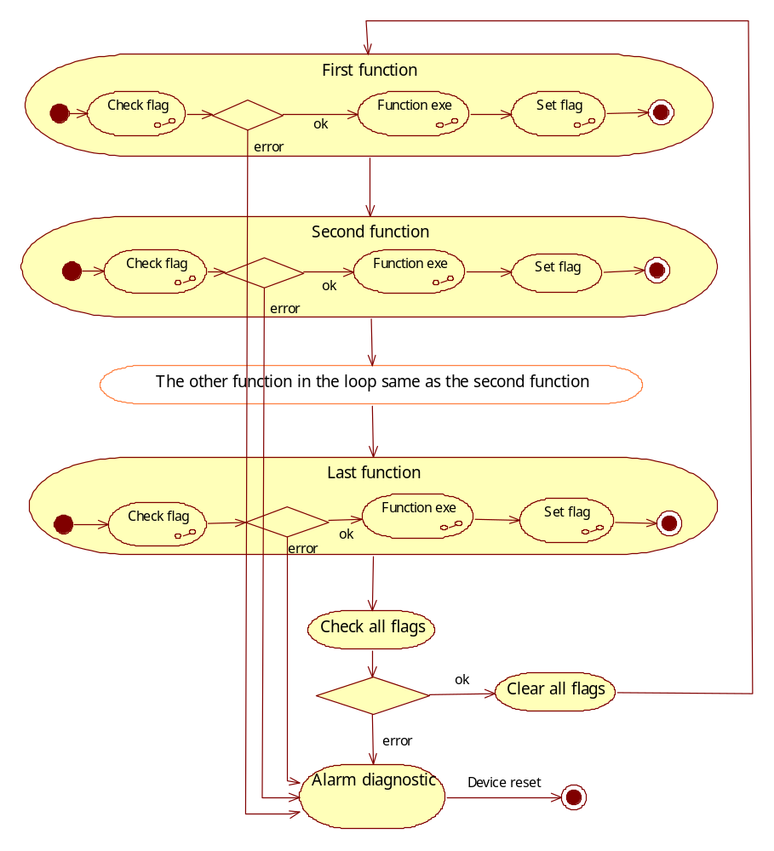

Figure 11 Program sequence monitor diagram

VT5 specified Application

Flash operation
The ElectronicServices subsystem provides the flash operation to put/get the hardware version which is stored in flash memory.

Frontend board command
The ElectronicServices subsystem provides interface to put/get data with frontend board to realize the functions such as read/write sensor threshold, hardware version, execute auto zero and self-diagnosis,etc.
The interface method is CmdPutQueue of frontendinterface subsystem, the frontend interface subsystem will process the communication.

PushButton function
The VT5 project do not use push button function, thus the corresponding program is deleted.

References
Ref. | Document
[1] | [RS012]Subsystem Software Requirement Specification ElectronicServices
[2] | [TP013]Software Subsystem Test Plan&Report ElectronicServices
[3]
[4]
Revision Chart
Rev. | Description of Version/Changes | Primary Authors | Date
00 | First Release | Ganapathi R | 2010-09-13
01 | Second Release  Update 2 Data Sheet , 3.2 Class Diagram , 3.3 Use Cases and 3.4 Objects List  Add 3.5.15 Save As Default and 3.5.16 Initialize NV  Remove password related function | Hao Wu | 2013-01-25
02 | Update object list, change Current out readback ADC tobe 7;  Add Check data CRC function in ES DD documents | Paul Li | 2013-05-28
03  04  05 | Add VT5 specified application design  Update section 3.6.5.1, 3.6.5.2, 3.6.11 and 3.6.16 accordting to current safety design.  Update the document according to TUV comments. | Spring Zhou  Merrick Huang  Merrick Huang | 2013-06-28  2013-10-18  2013-11-29
06 | Updated for CB firmware version 2.0.2:  Updated the section 3.6.6 to include the new voltage dropping check function | Sunil S. Patil | 2021-02-07

Review

Review-Participant:
Dept. | Name
R&D Lenno | Roberto Colombo | 2010-09-13 rev.00
INCRC Bangalore | Ashwin Herur | 2010-09-13 rev.00
INCRC Bangalore | Ganapathi R | 2010-09-13 rev.00

Dept. | Name
R&D ShangHai | Paul Li  Xiaojin Kuang | 2013-01-25 rev.01

Dept. | Name
R&D ShangHai | Merrick Huang  Lawrence Shi | 2013-07-04 rev.02

Dept. | Name
R&D ShangHai | Merrick Huang  Lawrence Shi | 2013-07-05 rev.03

Dept. | Name
R&D ShangHai | Lawrence Shi | 2013-10-24 rev.04

Dept. | Name
R&D ShangHai | Lawrence Shi | 2013-11-29 rev.05

Dept. | Name
R&D ShangHai | Jaden-JinDing Liu | 2021-02-08 rev.06

Decision of the Review:
 | Decision | next steps
 | Inspection passed without restrictions | Phase finished
Y | Inspection passed with restrictions | some changes must be done
 | Inspection not passed | Inspection must be repeated

Changes Are Proved:
The Reviewer confirms that all changes are done:
proved Rev: | Date: | Reviewer:
01 | 2010-09-13 | Roberto Colombo  Ashwin Herur

proved Rev: | Date: | Reviewer:
02 | 2013-01-25 | Xiaojin Kuang

proved Rev: | Date: | Reviewer:
03 | 2013-07-05 | Merrick Huang  Lawrence Shi

proved Rev: | Date: | Reviewer:
04 | 2013-10-24 | Lawrence Shi

proved Rev: | Date: | Reviewer:
05 | 2013-11-29 | Lawrence Shi

proved Rev: | Date: | Reviewer:
06 | 2021-02-08 | Jaden-JinDing Liu

Check List
 |  | Yes | No
1. | Is the software architecture distinct and documented? | X
2. | Fit the modules together? | X
3. | Are complex algorithms/procedures explained? | X
4. | Is a strategy for error handling designated? | X
5. | Is the configuration management system well prepared? | X
6. | Are all open issues transferred to the defects table? | X

Defect
No. | Checkpoint | Description | Major defect | Done date
1 |  | Add details related to function LoadRomDefaultSRV_ELETTRONICSERVICES() | N | 07-10-2009
2 |  | Add details of function ResetToDefaultSRV_ELETTRONICSERVICES() | N | 07-10-2009
3 |  | No State diagram for PUSH_BUTTONS_STATE_CHART  Answer: already done | N | No Action
4 |  | Update ReadbackTrimming() details | N | 07-10-2009
5 |  | Update SwWriteProtection() details. | N | 07-10-2009
6 |  | Revision needs to be updated in the page headers. | N | 07-10-2009
7 |  | Add Save As Default | N | 17-01-2013
8 |  | Add IO Pin Test | N | 17-01-2013
9 |  | Update Use Cases | N | 17-01-2013
10 |  | Update Objects List | N | 17-01-2013
11 |  | Add Initialize NV | N | 18-01-2013
12 | 3.7.3 | Note that VT5 do not use PushButton function | N | 04-07-2013
13 | 3.6.19 | Add program run sequence design description | Y | 04-07-2013
14 |  | The author and the date shall be changed | N | 2021-02-08

